HackerRank – Practice – SQL

*Author: Preethi Ann Jacob*

*Default Language: MySQL. Otherwise MS SQL server*

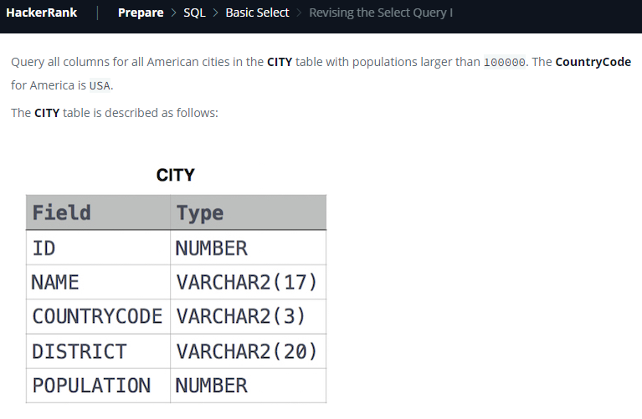

select * from City

where population>100000 and countrycode='USA'

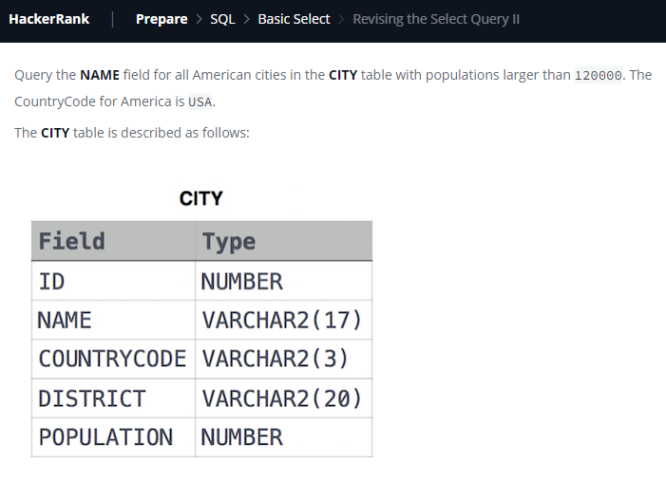

select name from City where population>120000 and CountryCode='USA';

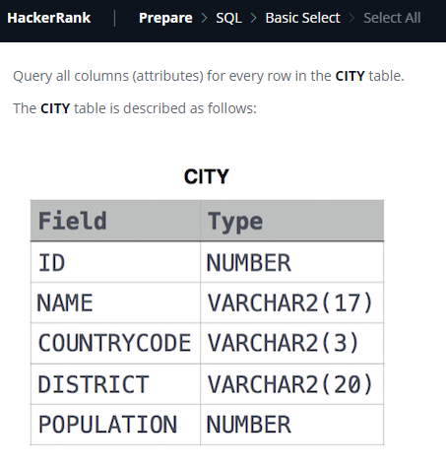

select * from city

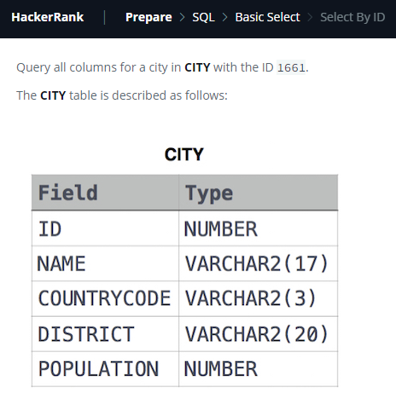

select * from city where id=1661

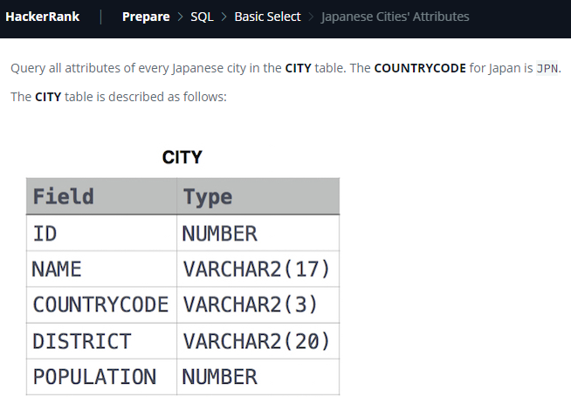

Select * from City where countrycode='JPN'

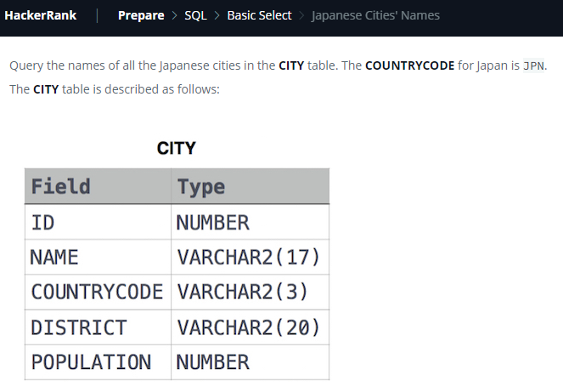

Select name from city where countrycode='JPN'

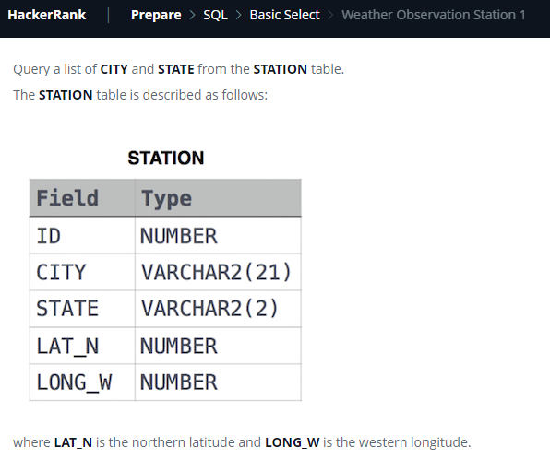

select city,state from station

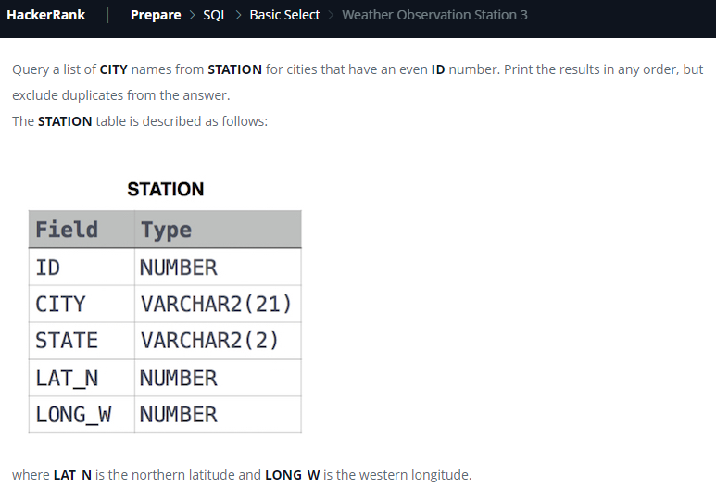

select distinct city from station where id%2=0

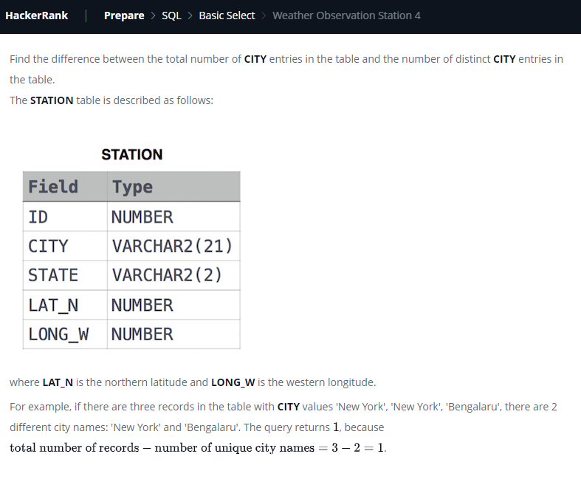

select count(city)-count(distinct city) from station

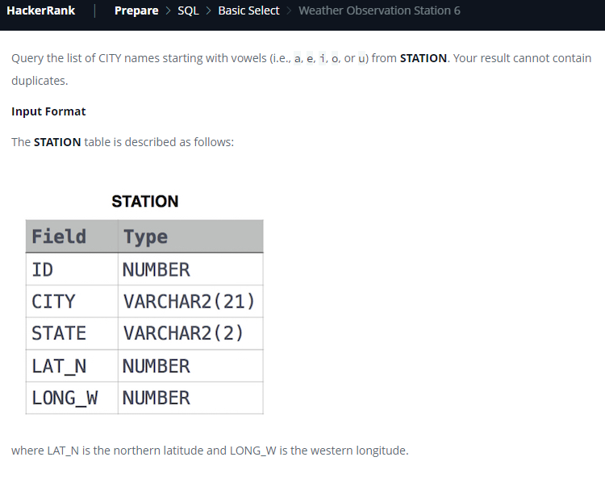

select distinct city from station where left(city,1) in ('a','e','i','o','u');

select distinct city from station where substring(city,1,1) in ('a','e','i','o','u');

select distinct city from station where city regexp '^[aeiouAEIOU]';

select distinct city from station where city like 'a%' or city like 'e%' or city like 'i%' or city like 'o%' or city like 'u%';

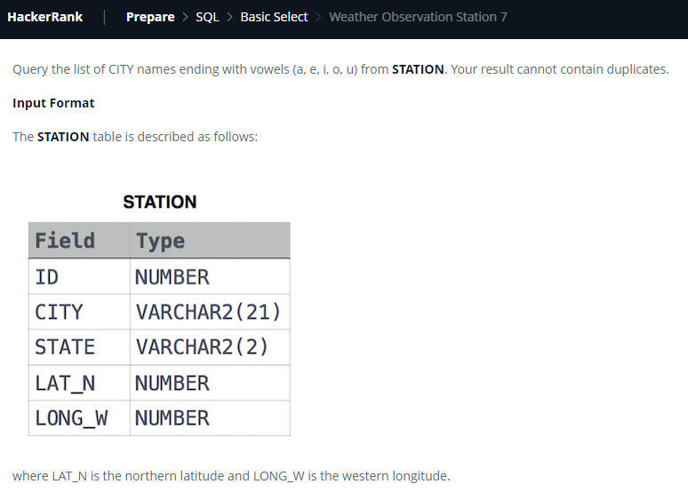

select distinct city from station where city regexp '[aeiouAEIOU]$'

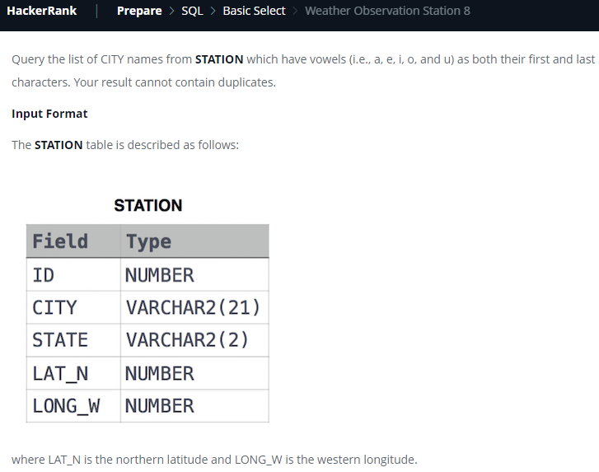

select city from station where city regexp '^[aeiouAEIOU].*[aeiouAEIOU]$'

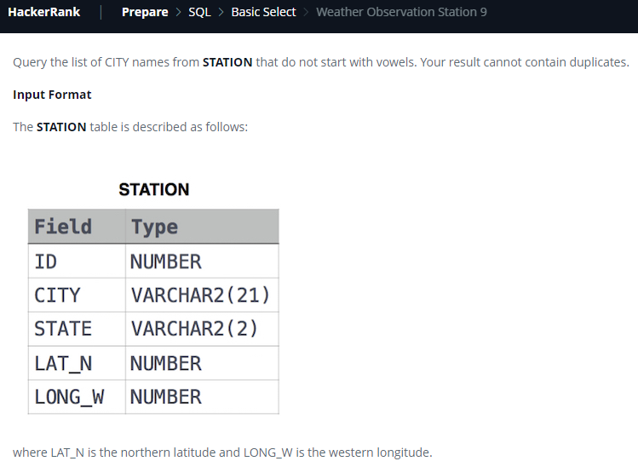

select distinct city from station where city regexp '^[^aeiouAEIOU]';

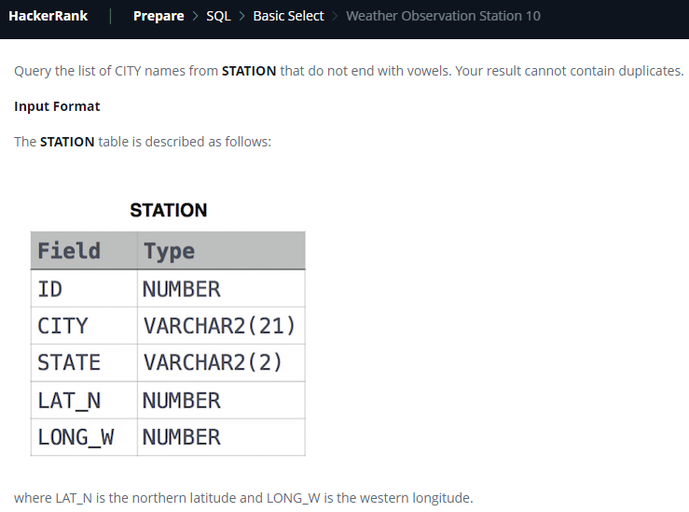

select distinct city from station where city regexp '[^aeiouAEIOU]$';

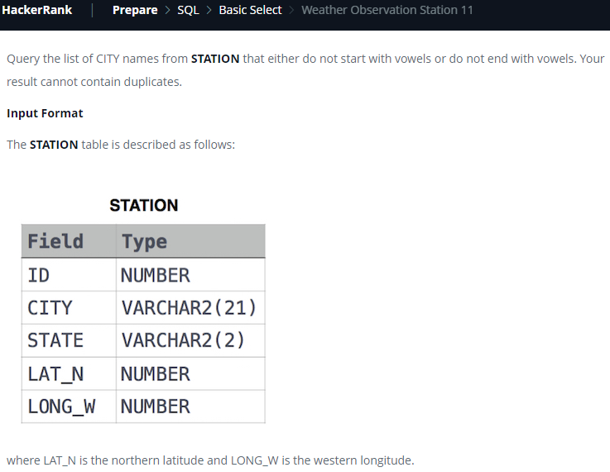

select distinct city from station where city regexp '^[^aeiouAEIOU]|[^aeiouAEIOU]$'

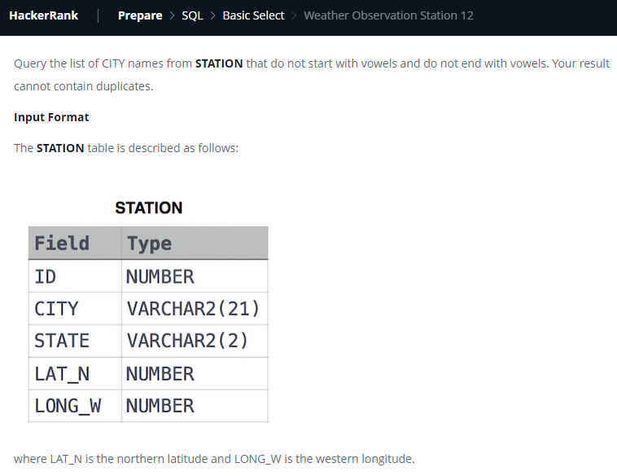

select distinct city from station where city regexp '^[^aeiouAEIOU].*[^aeiouAEIOU]$'

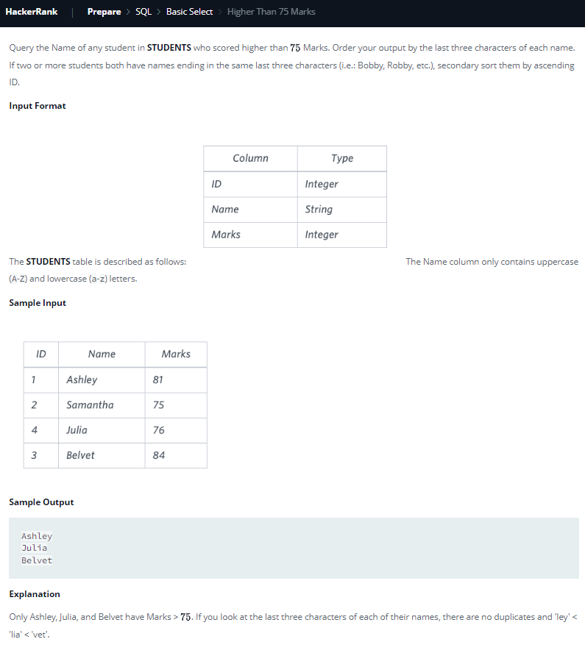

select name from students where marks>75

order by substring(name,-3,3), id;

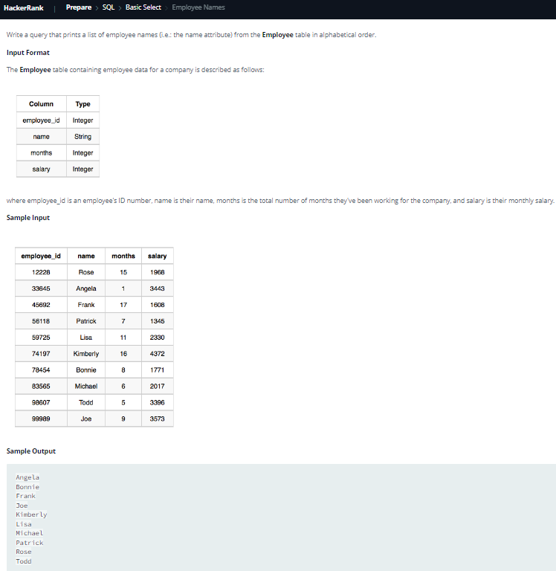

select name from employee order by name;

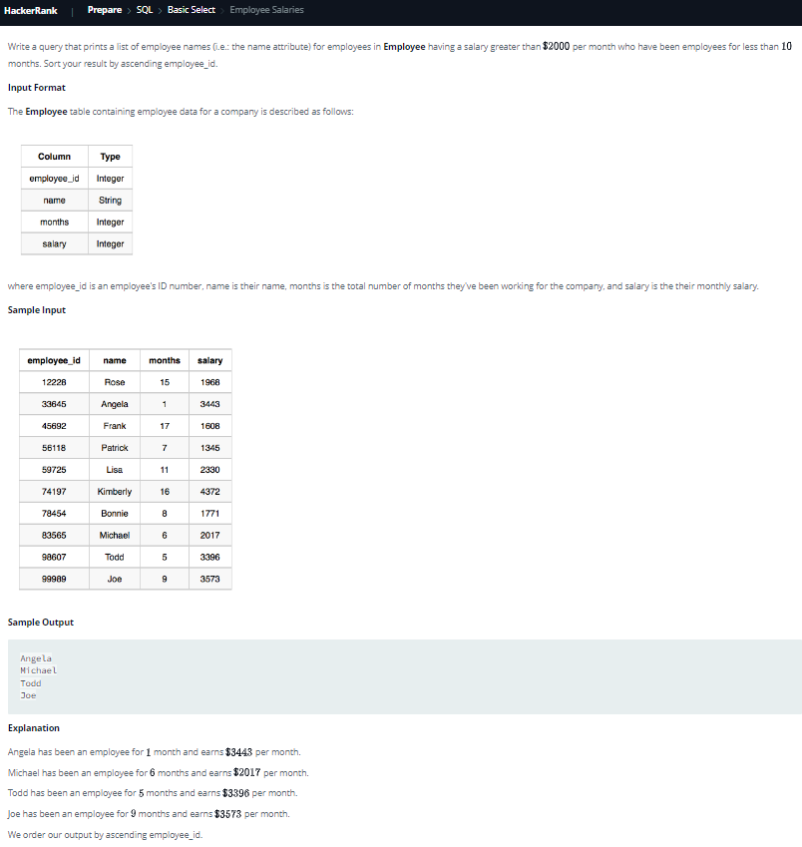

select name from Employee where salary>2000 and months<10 order by employee_id;

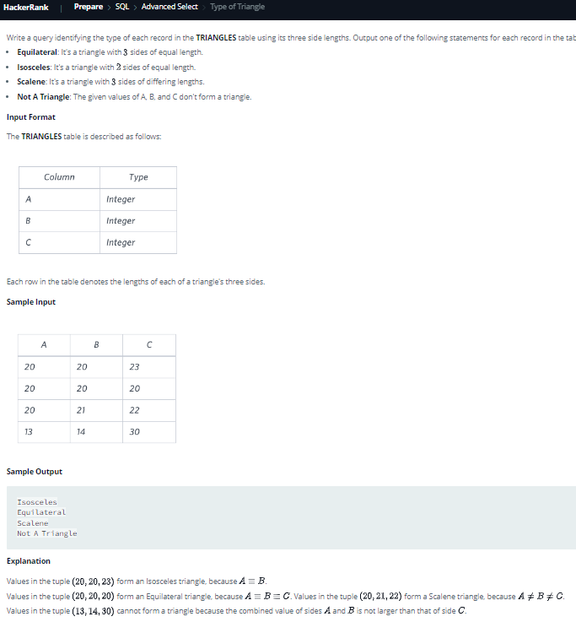

select

case

when A+B<=C or A+C<=B or B+C<=A then 'Not A Triangle'

when A=B and B=C then 'Equilateral'

when A=B or B=C or A=C then 'Isosceles'

else 'Scalene'

end

from triangles;

[Reason: Approach: A triangle is valid if sum of its two sides is greater than the third side. If three sides are a, b and c, then three conditions should be met. 

1.a + b > c

2.a + c > b

3.b + c > a

]

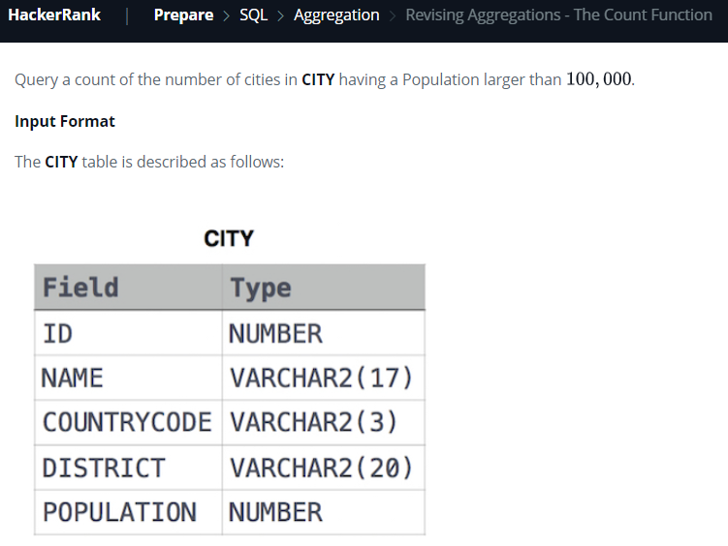

select count(*) from city where population>100000;

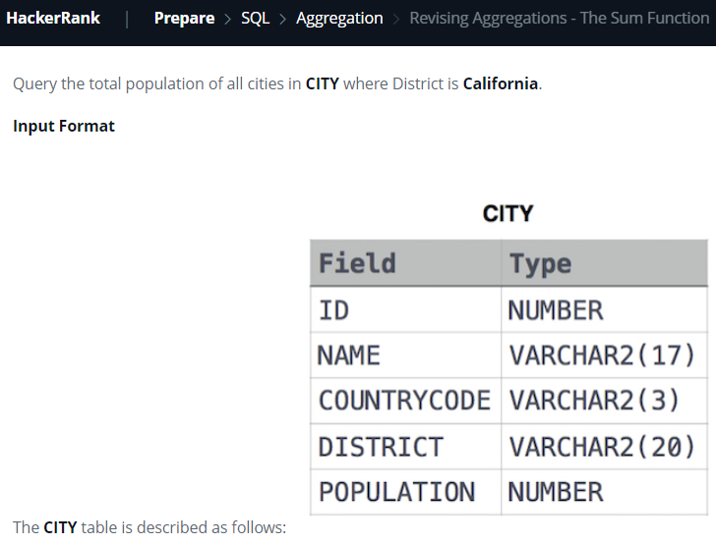

select sum(population) from city where district ='California';

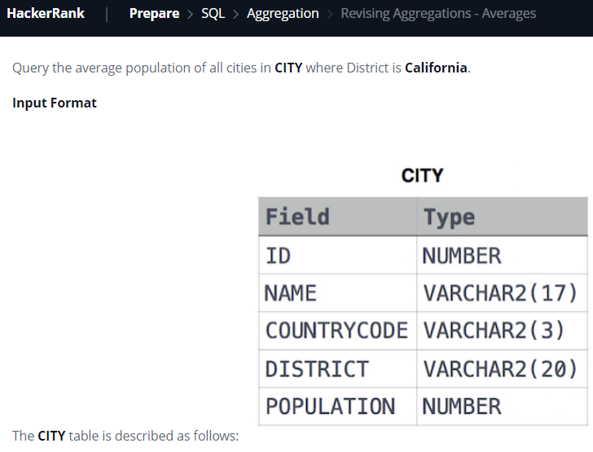

select avg(population) from city where district = 'California';

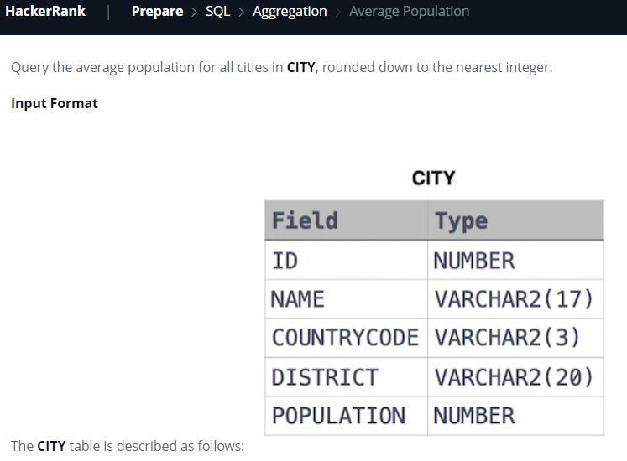

select round(avg(population),0) from city;

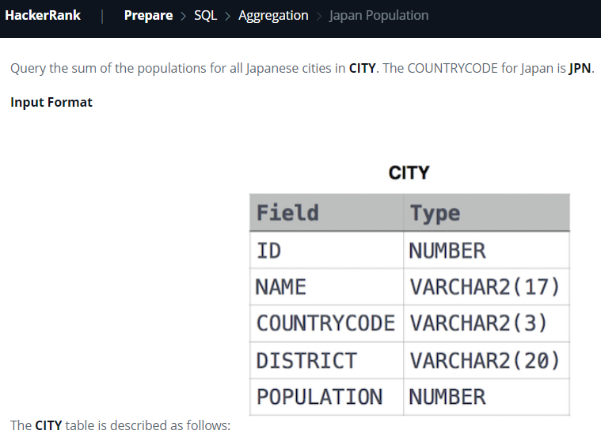

select sum(population) from city where countrycode='JPN';

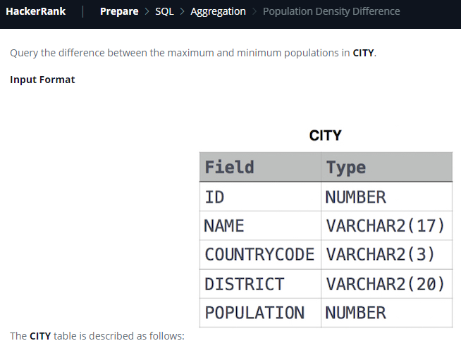

select max(population)-min(population) from city;

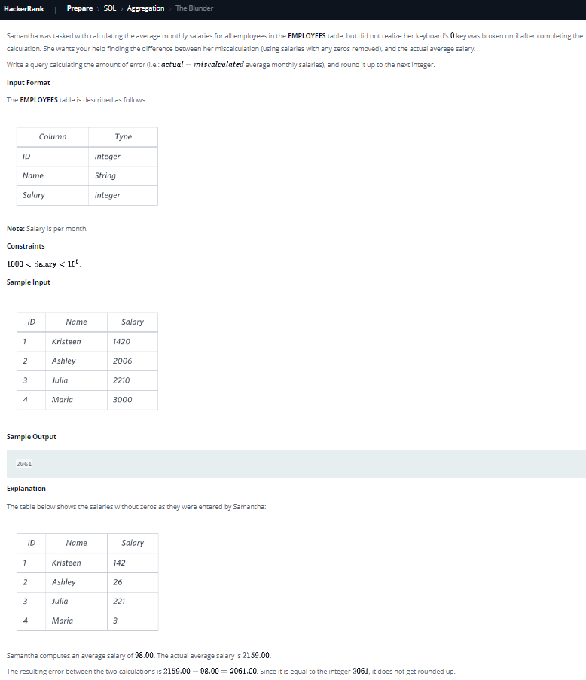

select ceil(avg(salary)-avg(replace(salary,'0',''))) from employees;

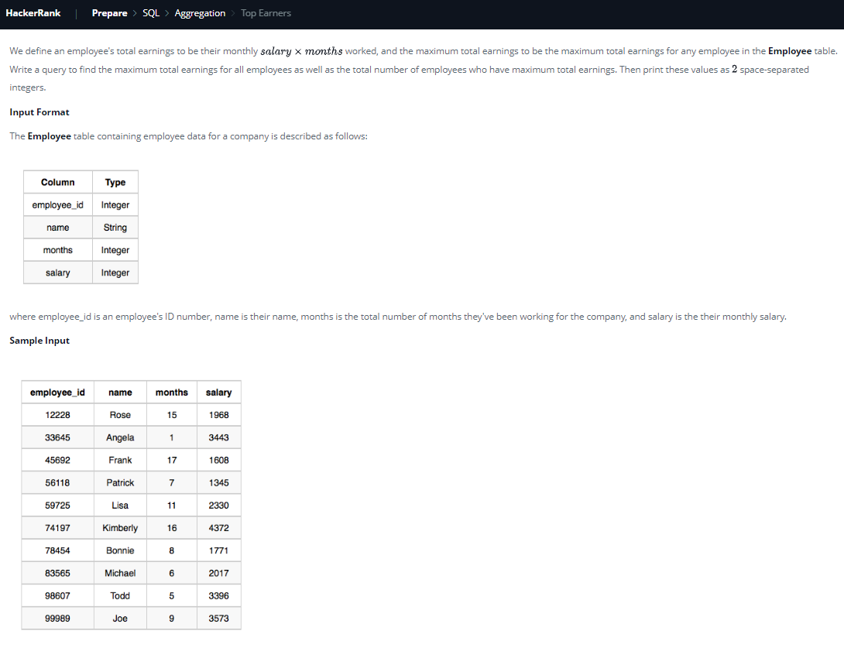

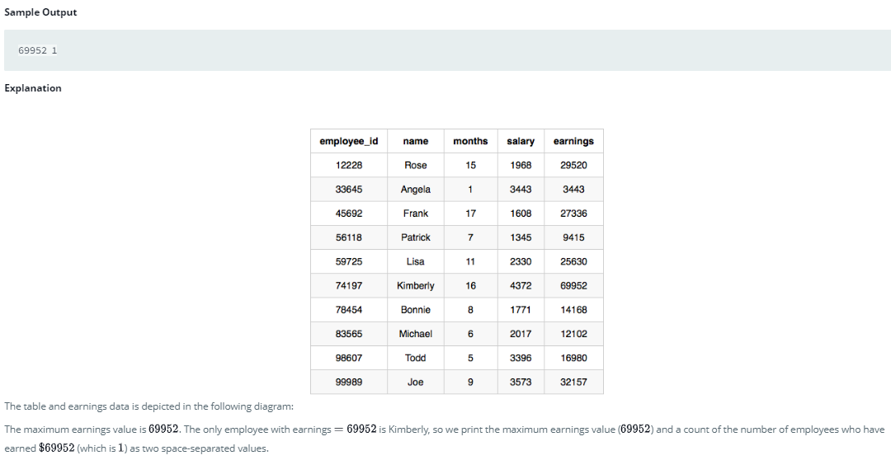

select max(salary*months),count(*) from employee

where salary*months = (select max(salary*months) from employee);

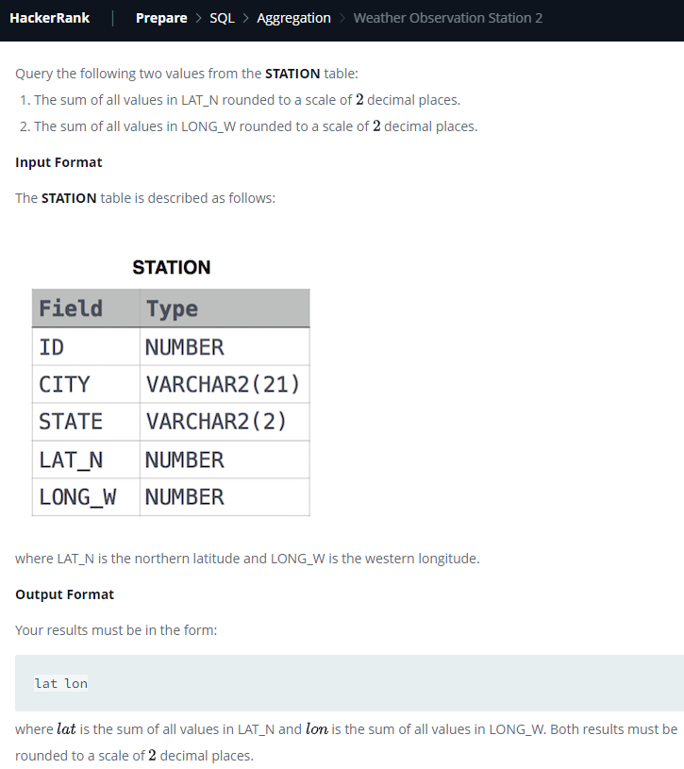

select round(sum(lat_n),2),round(sum(long_w),2) from station;

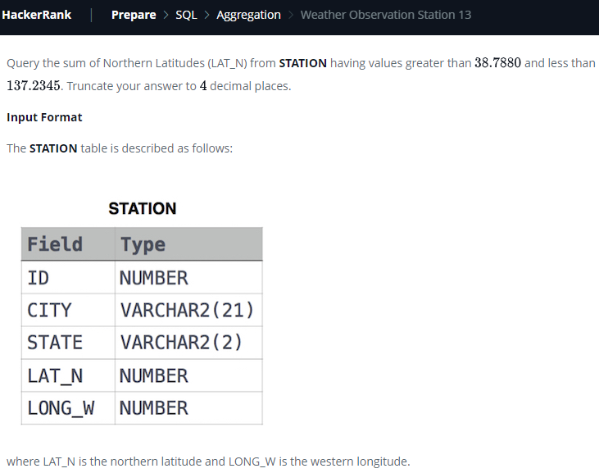

select round(sum(lat_n),4) from station

where lat_n between 38.7880 and 137.2345;

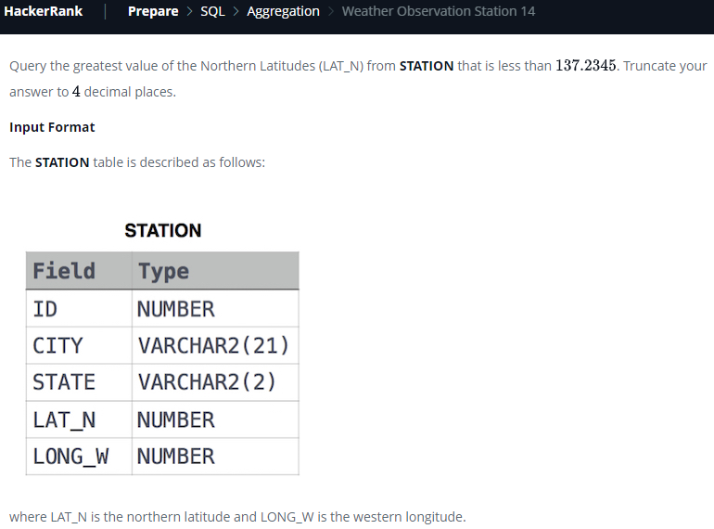

select round(max(lat_n),4) from station where lat_n<137.2345

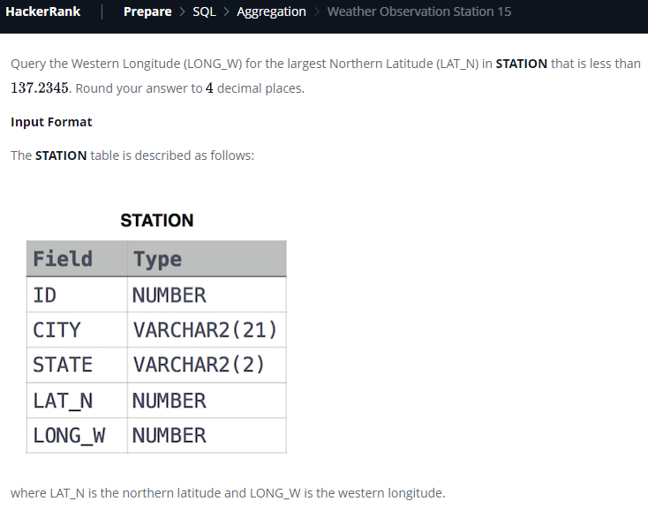

select round(long_w,4) from station

where lat_n = (select max(lat_n) from station where lat_n<137.2345)

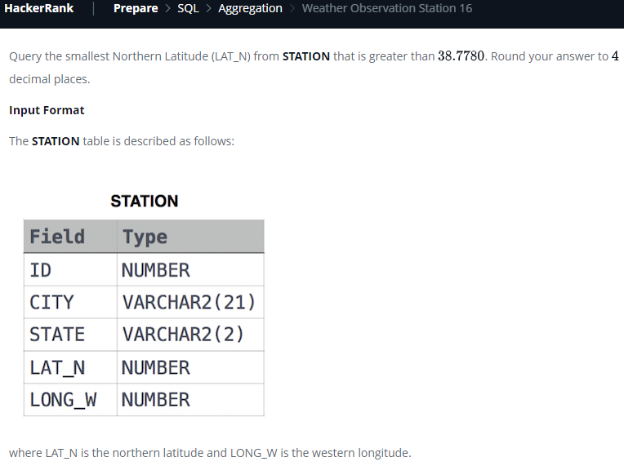

select round(min(lat_n),4) from station where lat_n>38.7780

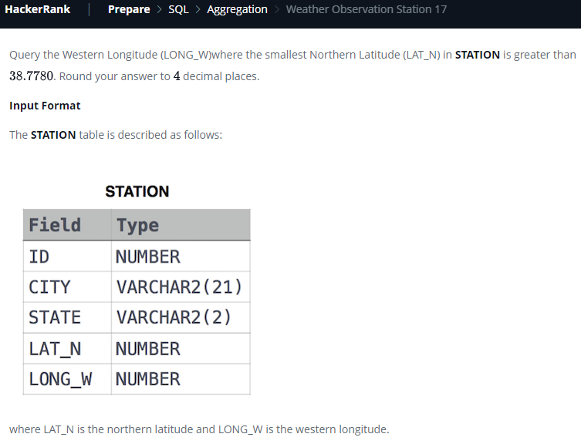

select round(long_w,4) from station

where lat_n = (select min(lat_n) from station where lat_n>38.7780)

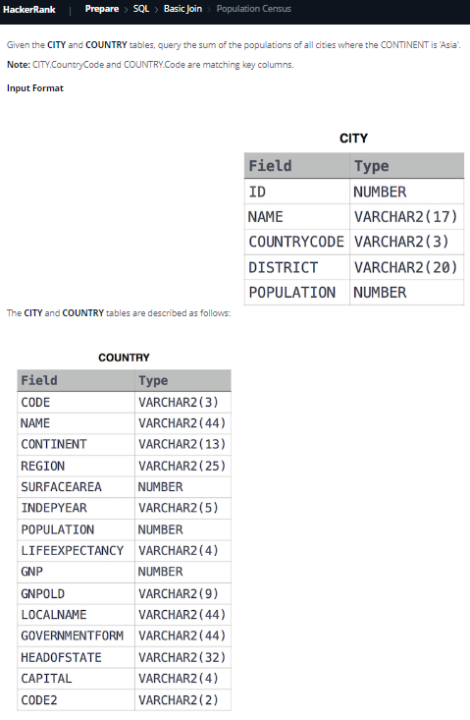

select sum(A.population) from city A

inner join country B on A.countrycode=B.code

where B.continent = 'Asia'

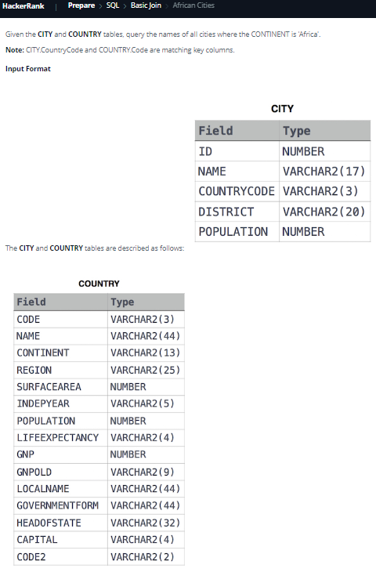

select A.name from City A inner join Country B on A.countrycode=B.code where B.continent='Africa'

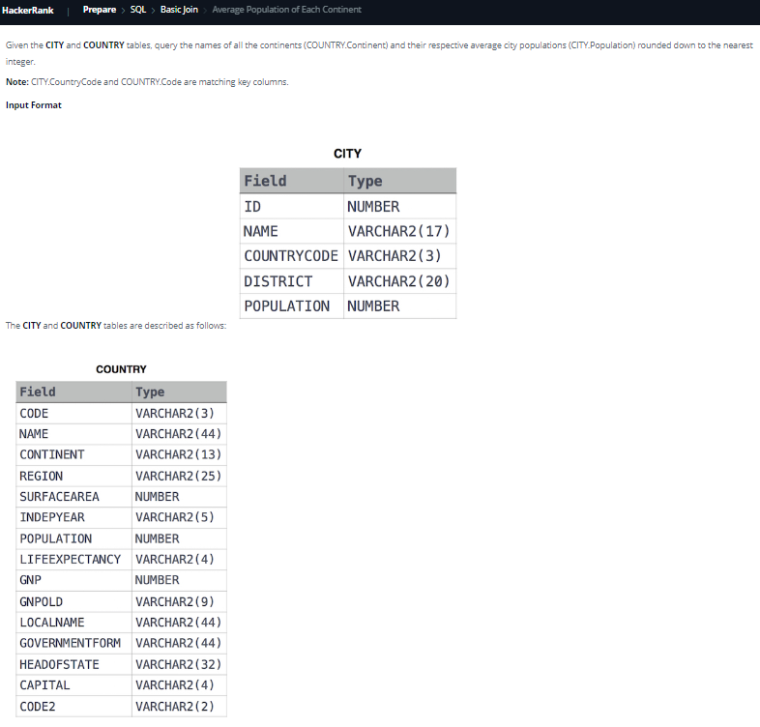

select B.continent, floor(avg(A.population))

from Country B inner join City A on A.countrycode=B.code

group by B.continent

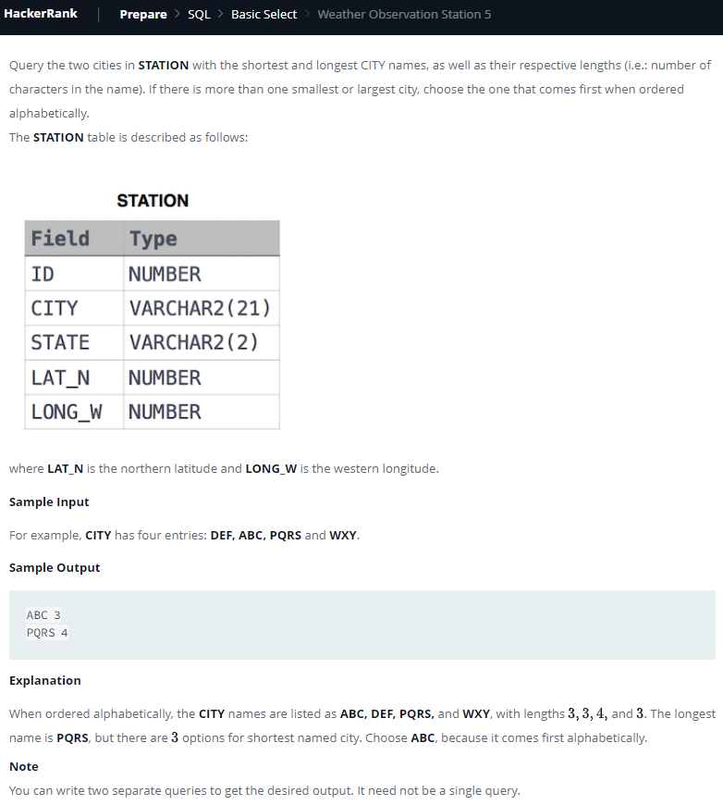

select city,length(city) from station order by length(city),city limit 1;

select city,length(city) from station order by length(city)desc,city limit 1;

OR Another way:

(select city,length(city) from station order by length(city),city limit 1) union

(select city,length(city) from station order by length(city)desc,city limit 1)

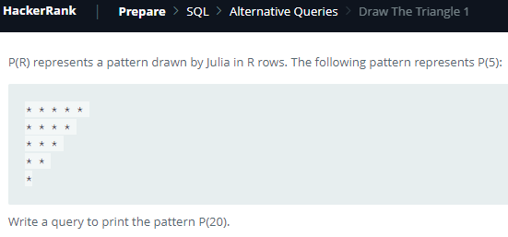

set @num=21;

select repeat('* ',@num:=@num-1) from information_schema.tables limit 20;

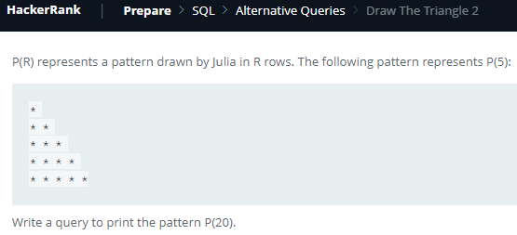

set @num=0;

select repeat('* ',@num:=@num+1) from information_schema.tables limit 20; 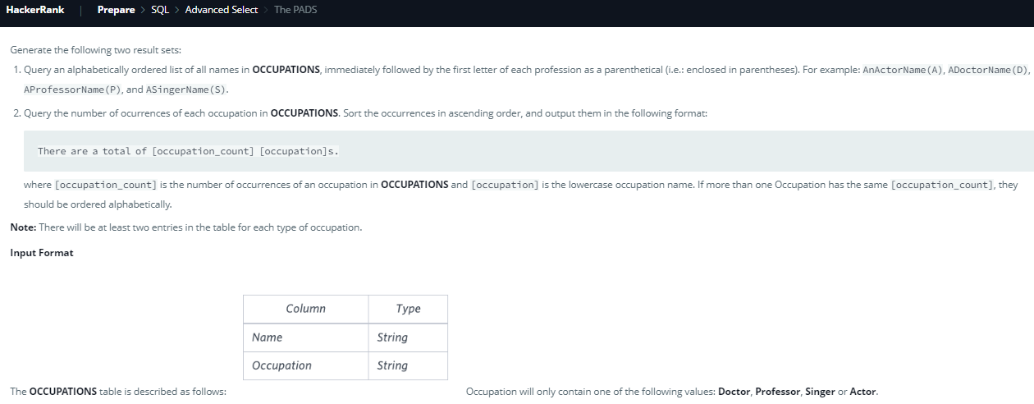

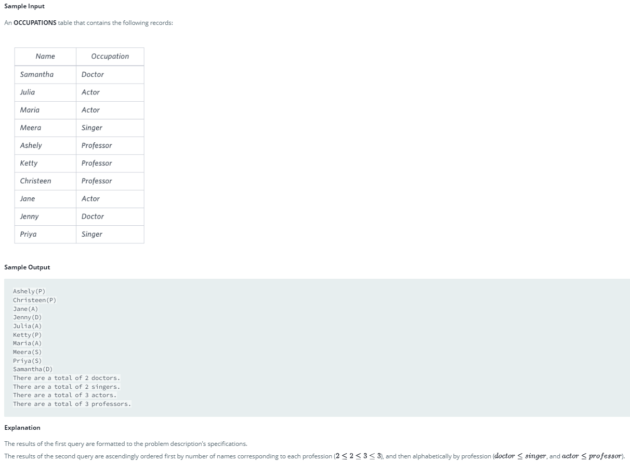

select concat(name, '(', left(occupation,1) ,')') from occupations order by name;

select concat('There are a total of ', count(*),' ', lower(occupation), 's.') from occupations group by occupation order by count(*),occupation;

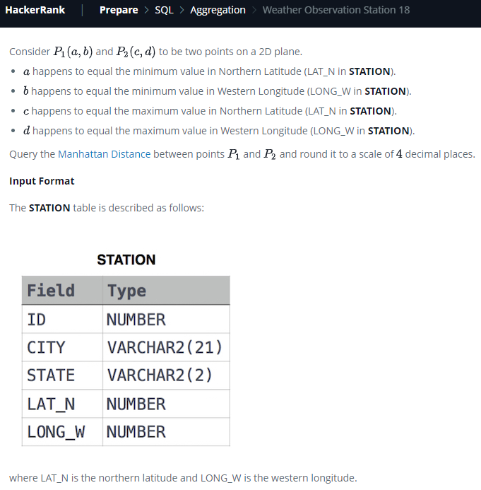

select round(abs(a-c)+abs(b-d),4) from (select min(lat_n) a, min(long_w) b, max(lat_n) c, max(long_w) d from station) as T;

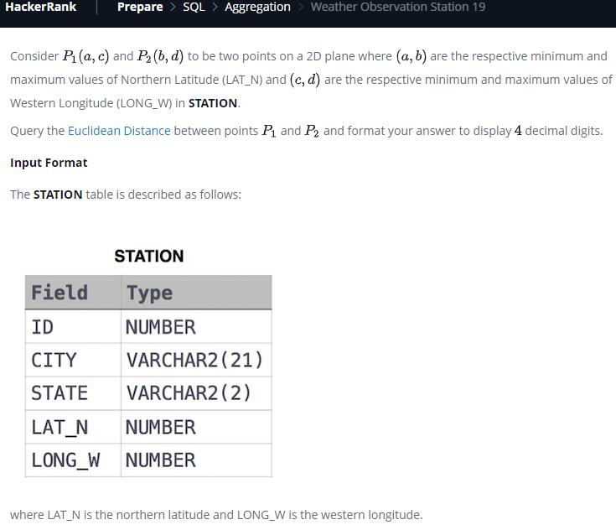

select round( sqrt( power(b-a,2) + pow(d-c,2) ) , 4)

from (select min(lat_n) a, max(lat_n) b, min(long_w) c, max(long_w) d from station) as T;

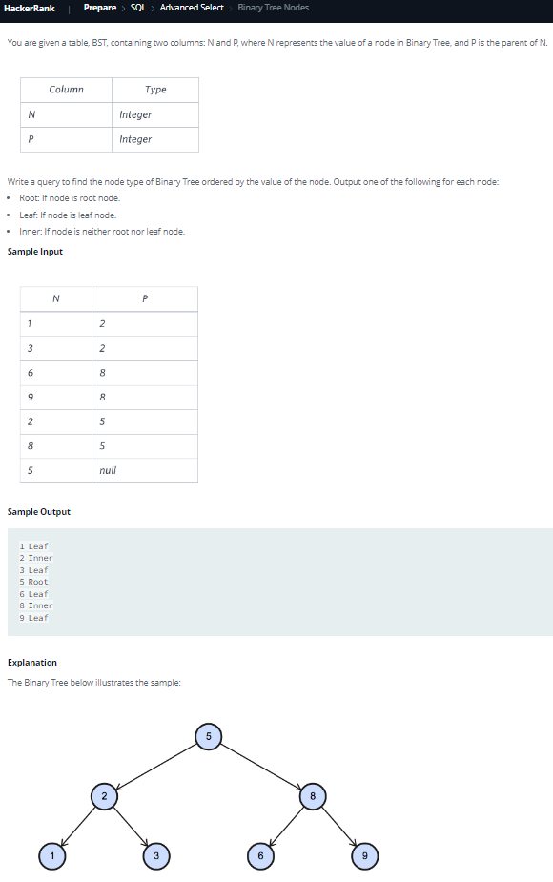

select n, case

when p is null then 'Root'

when n in (select p from bst) then 'Inner'

else 'Leaf'

end

from bst order by n;

OR Another way:

select n, case

when p is null then 'Root'

when n not in (select p from bst where p is not null) then 'Leaf'

--Remember to use ‘p is not null’ with ‘not in’

else 'Inner'

end

from bst order by n;

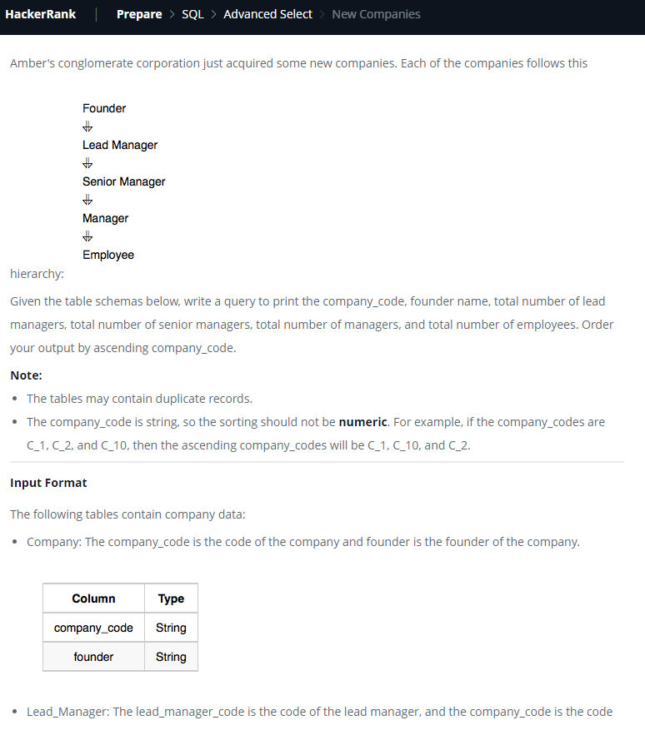

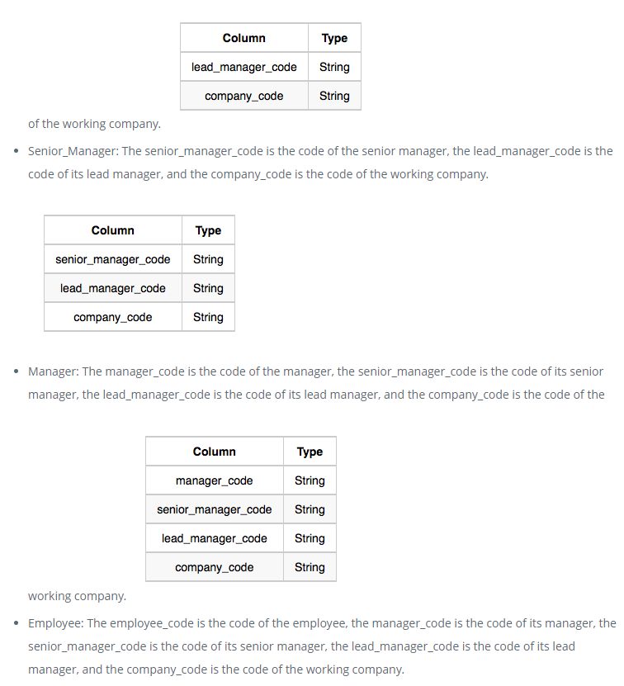

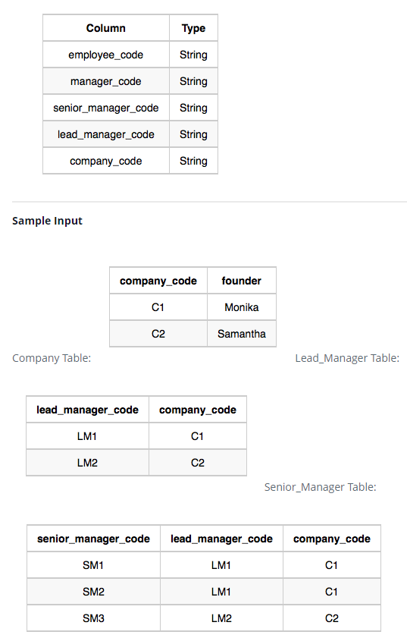

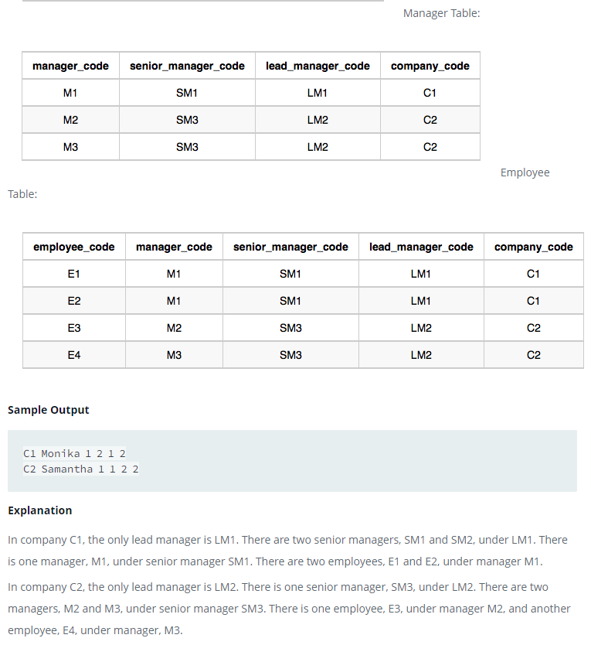

select C.company_code, C.founder, count(distinct L.lead_manager_code), count(distinct S.senior_manager_code), count(distinct M.manager_code), count(distinct E.employee_code)

from company C

inner join lead_manager L on C.company_code=L.company_code

inner join senior_manager S on S.company_code=C.company_code and S.lead_manager_code=L.lead_manager_code

inner join manager M on M.company_code=C.company_code and M.lead_manager_code=L.lead_manager_code and M.senior_manager_code=S.senior_manager_code

inner join employee E on E.company_code=C.company_code and E.lead_manager_code=L.lead_manager_code and E.senior_manager_code=S.senior_manager_code and E.manager_code=M.manager_code

group by C.company_code, C.founder

order by company_code;

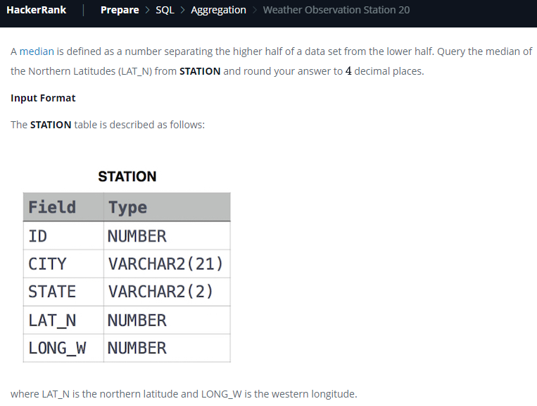

set @rowNo=-1;

select round(avg(lat_n),4) from

(select @rowNo:=@rowNo+1 as rowIndex, lat_n from station order by lat_n) T

where T.rowIndex in (floor(@rowNo/2),ceil(@rowNo/2));

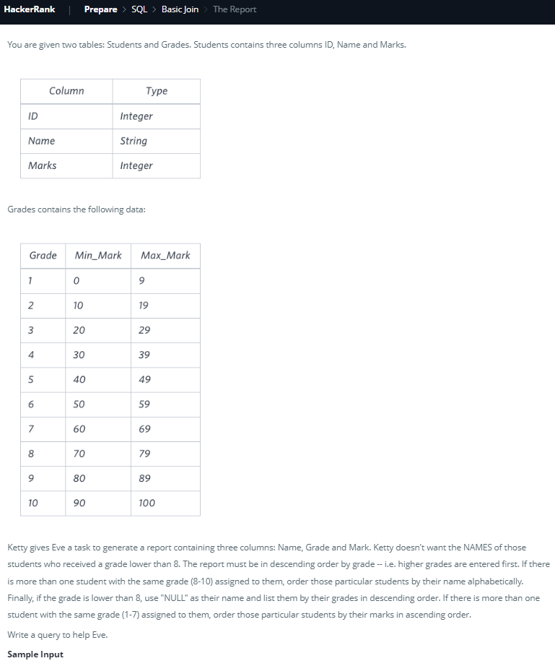

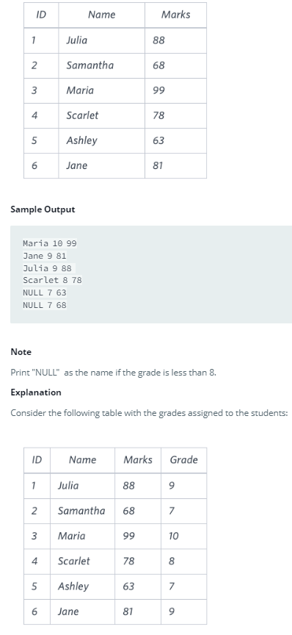

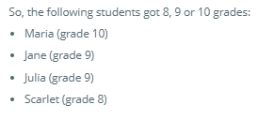

select

case

when G.grade>=8 then S.name

else NULL

end

,G.grade,S.marks

from Students S inner join Grades G on S.marks between G.min_mark and G.max_mark

order by G.grade desc, S.name, S.marks;

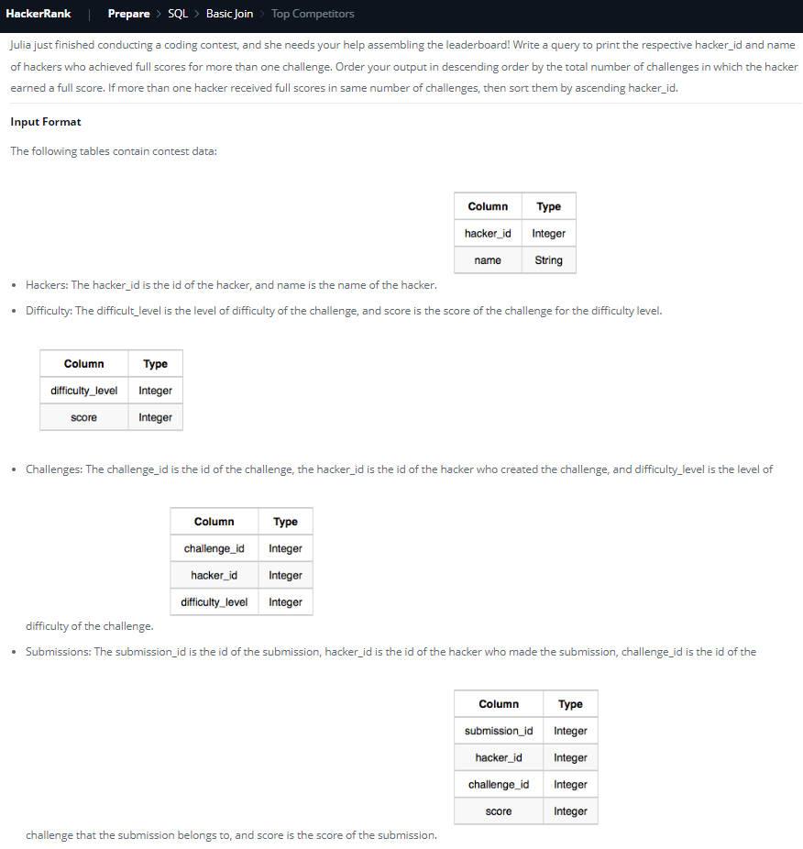

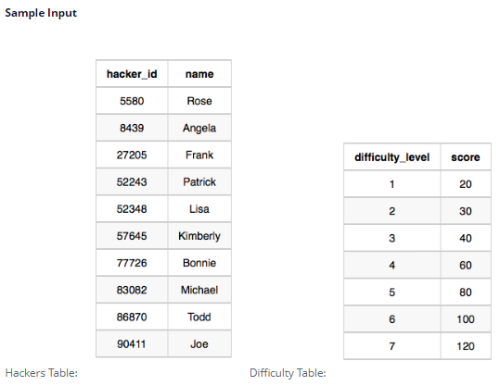

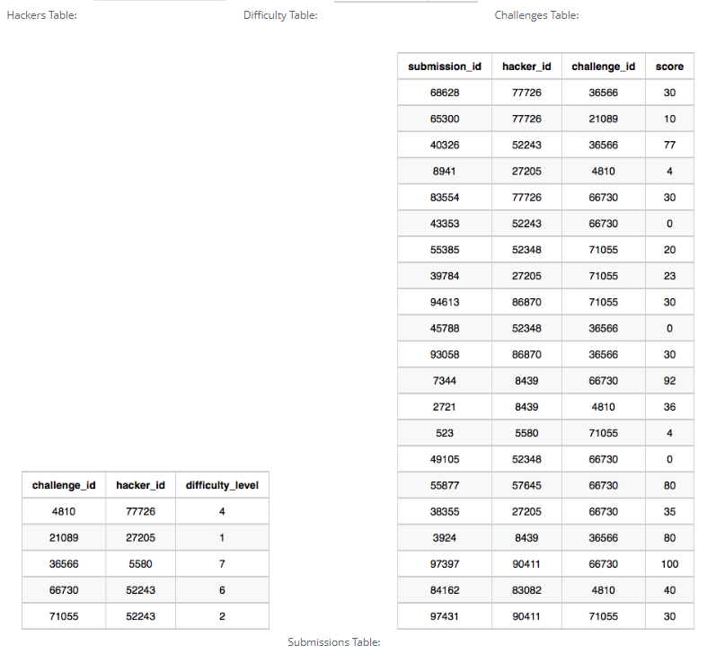

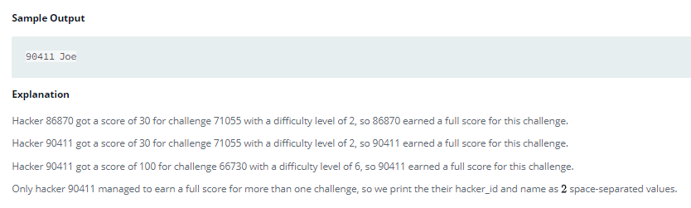

select T.hacker_id, T.name

from

(select S.hacker_id,H.name,count(*)

from Submissions S

inner join Hackers H on S.hacker_id=H.hacker_id

inner join Challenges C on S.challenge_id = C.challenge_id

inner join Difficulty D on C.difficulty_level = D.difficulty_level and S.score=D.score

group by S.hacker_id, H.name

having count(*)>1

order by count(*) desc, S.hacker_id) T

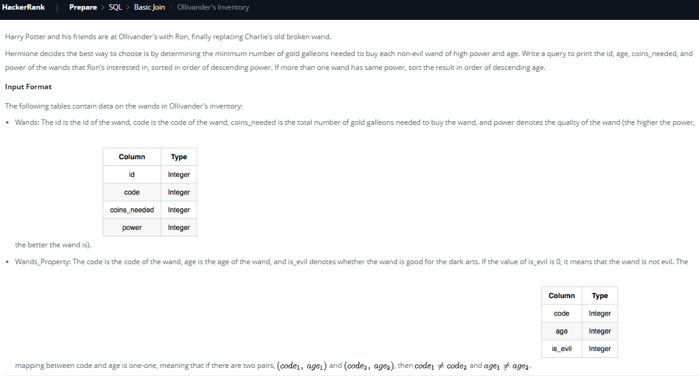

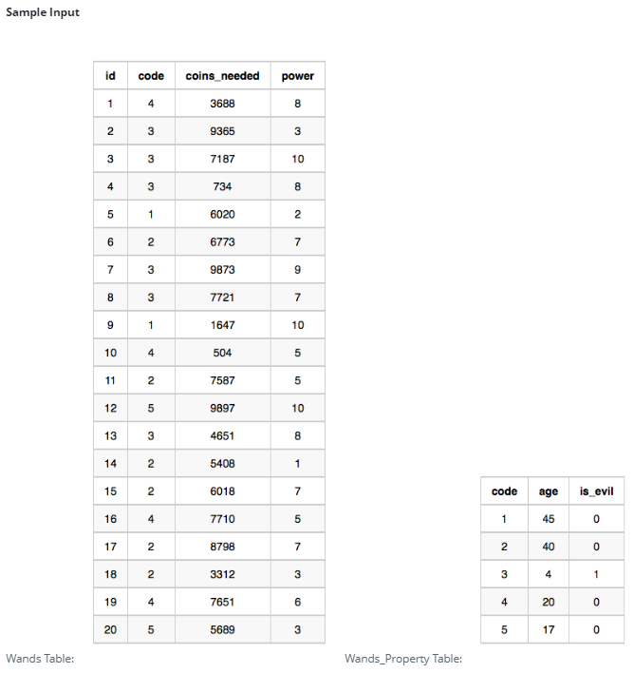

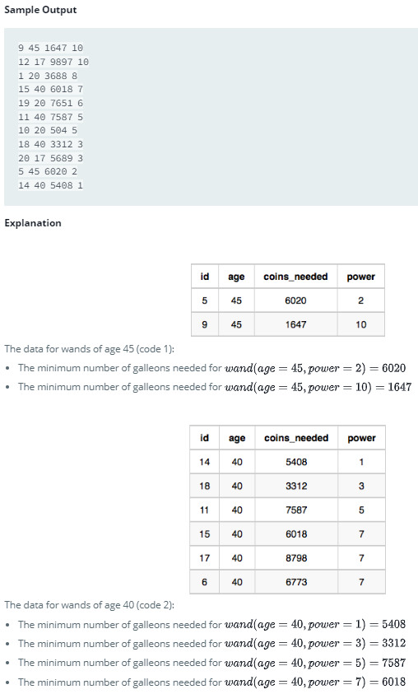

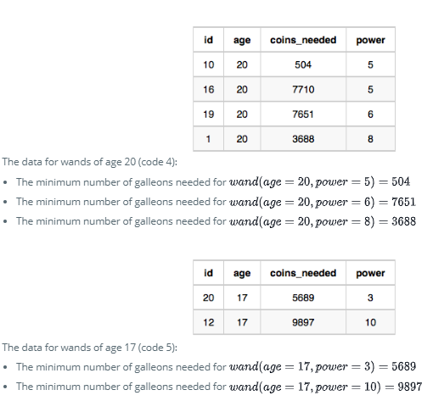

select W.id, T.age, T.minCoins, T.power

from

Wands W

inner join Wands_property P on W.code=P.code

inner join (select W.power, P.age, min(W.coins_needed) as minCoins

from Wands W inner join Wands_property P on W.code=P.code and P.is_evil=0

group by W.power, P.age) T

on T.minCoins=W.coins_needed and T.power=W.power and T.age=P.age

order by T.power desc, T.age desc

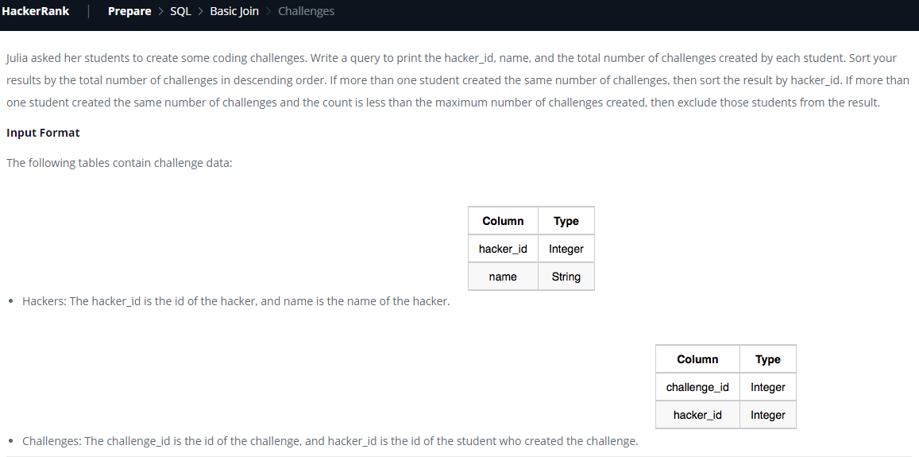

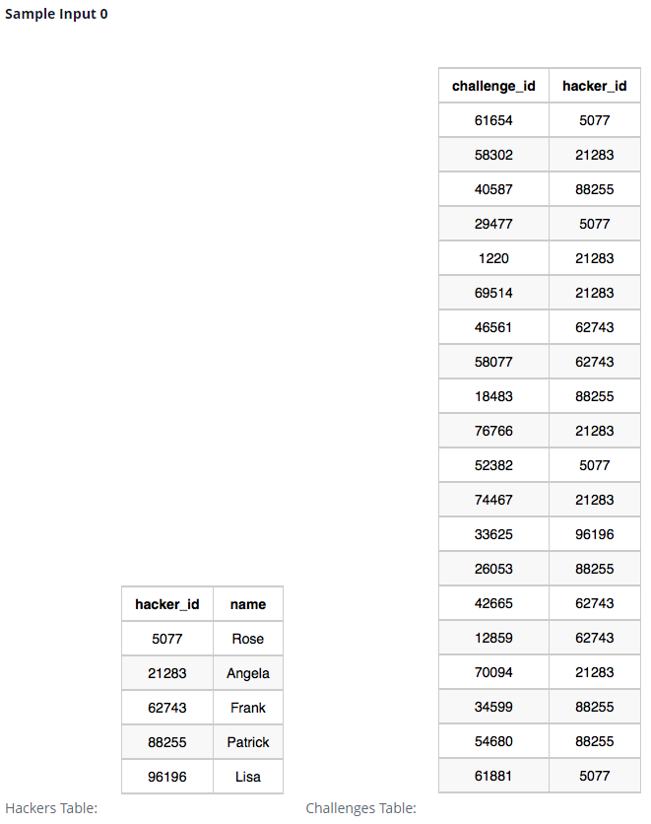

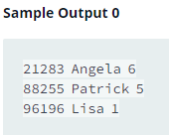

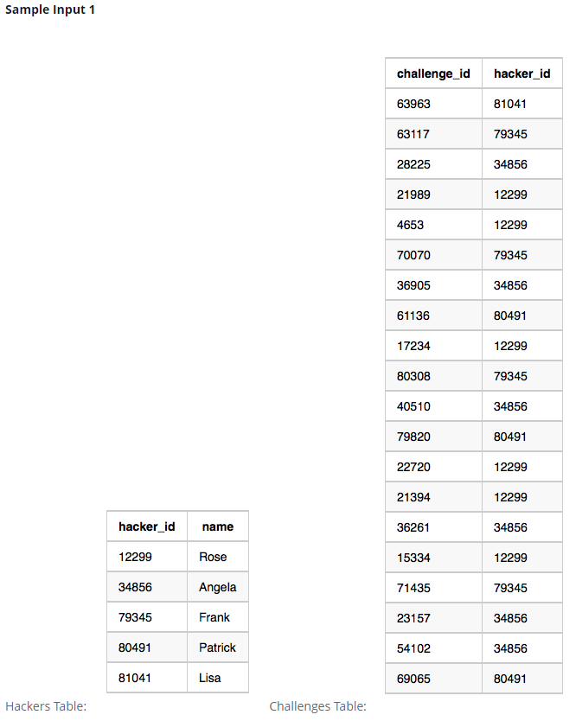

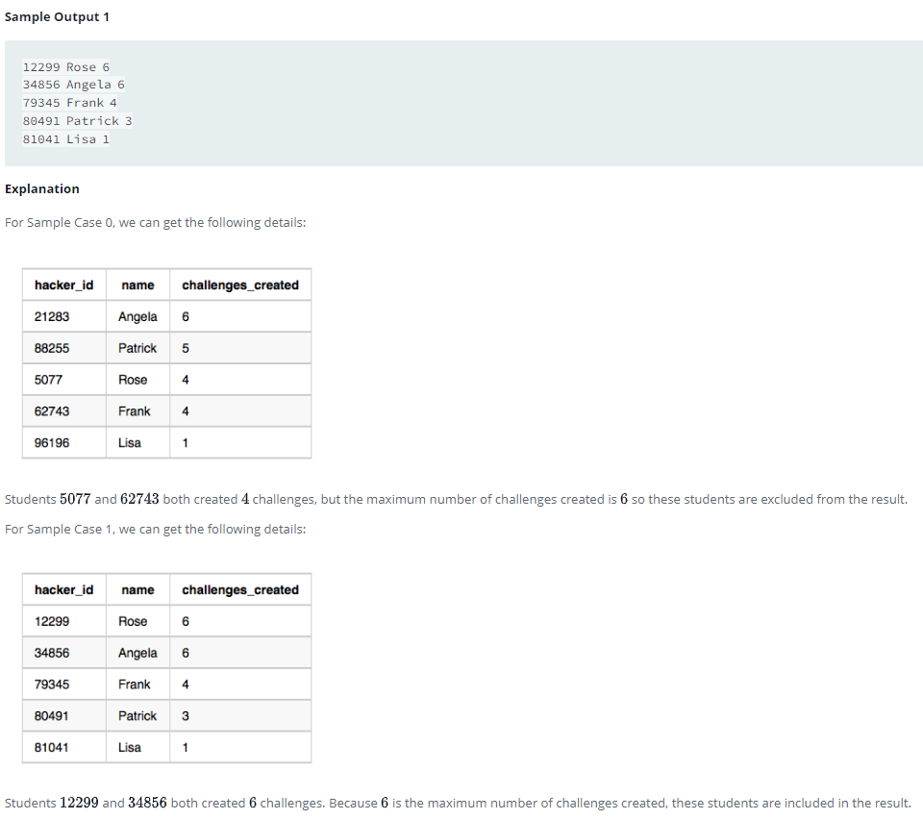With

T1 as (select hacker_id, count(*) as cc from Challenges group by hacker_id),

T2 as (select cc, count(cc) as countcc from T1 group by cc)

select T1.hacker_id, H.name, T1.cc

from T1 inner join Hackers H on T1.hacker_id=H.hacker_id

inner join T2 on T2.cc=T1.cc

where T2.countcc=1 or (T1.cc in (select max(cc) from T1))

order by T1.cc desc, T1.hacker_id;

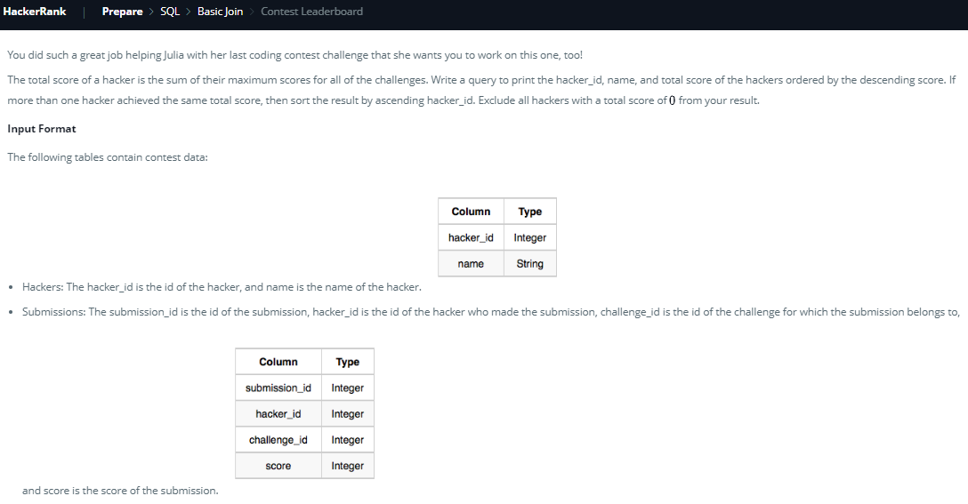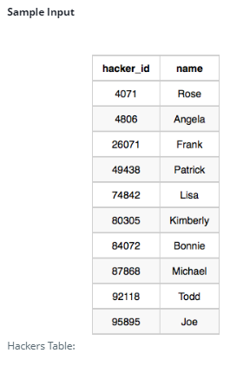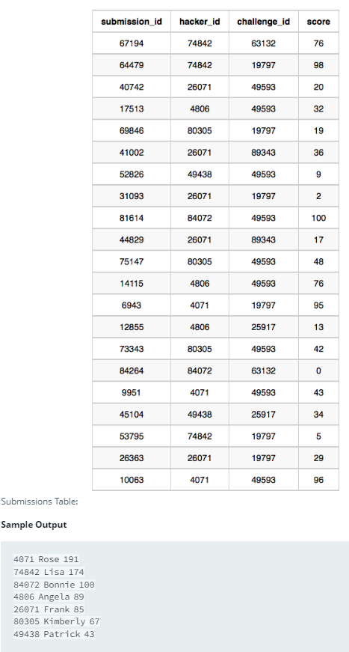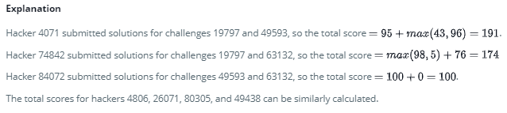

select T.hacker_id, H.name, sum(T.maxScore) as totalScore

from (select hacker_id,challenge_id,max(score) as maxScore from Submissions group by hacker_id,challenge_id) T

inner join Hackers H on T.hacker_id=H.hacker_id

group by T.hacker_id, H.name

having totalScore>0

order by totalScore desc, T.hacker_id

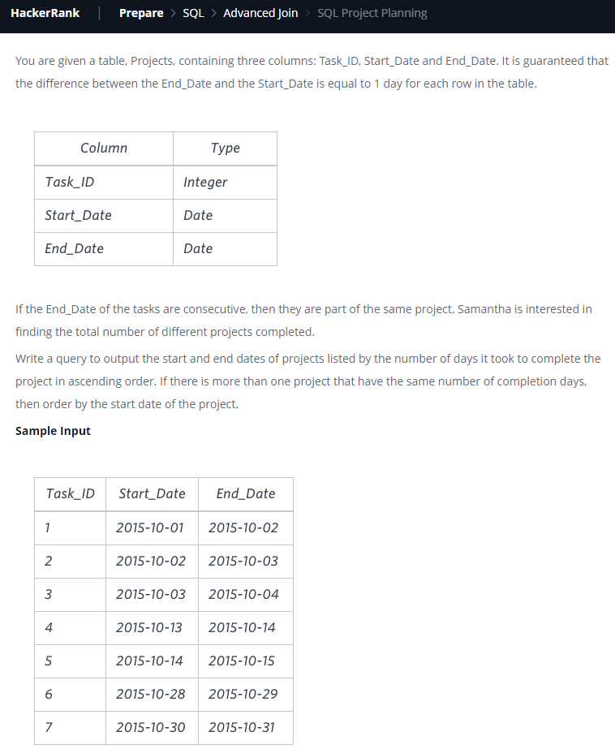 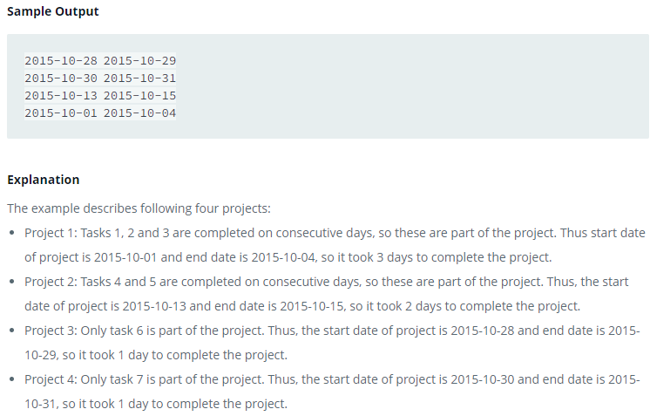

with

T(sd1,ed1,sd2,ed2,sd3,ed3) as

(select

Yesterday.start_date, Yesterday.end_date,

Today.start_date, Today.end_date,

Tomorrow.start_date, Tomorrow.end_date

from

Projects Yesterday

right join Projects Today on Yesterday.end_date = Today.start_date

left join Projects Tomorrow on Today.end_date = Tomorrow.start_date),

StartDate(projectNo,project_start_date) as (select row_number() over (order by sd2),sd2 from T where sd1 is null),

EndDate(projectNo,project_end_date) as (select row_number() over (order by ed2), ed2 from T where sd3 is null)

select sd.project_start_date, ed.project_end_date from StartDate sd inner join EndDate ed on sd.projectNo=ed.projectNo

order by (ed.project_end_date-sd.project_start_date), sd.project_start_date;

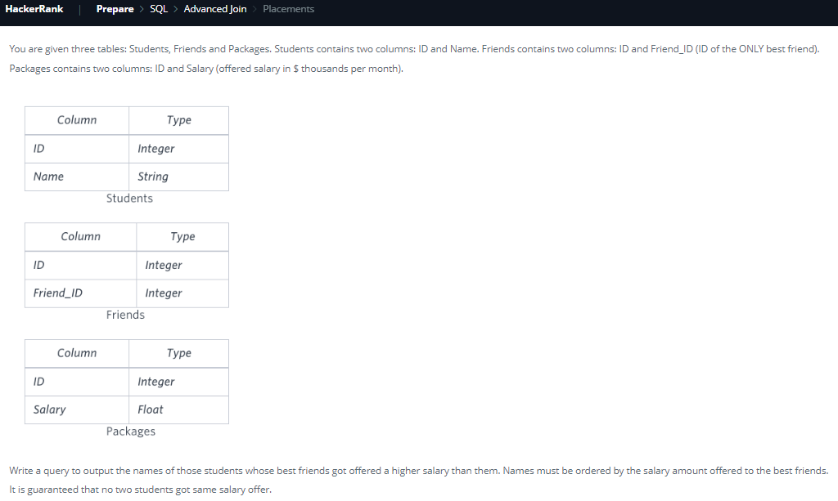

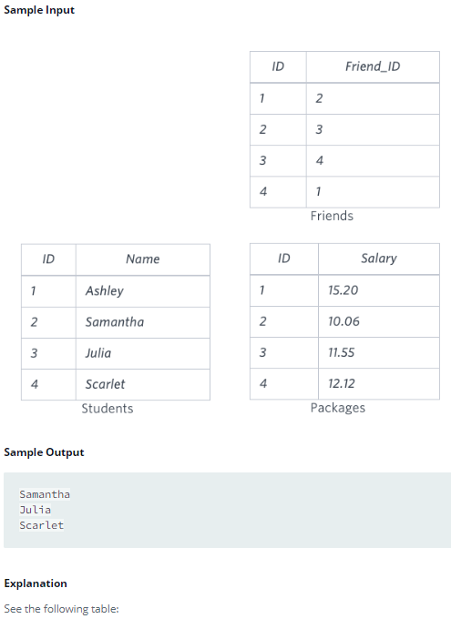

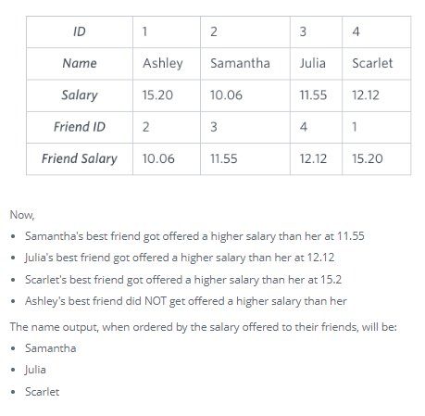

select S_me.name

from Friends F

inner join Students S_me on F.id=S_me.id

inner join Packages P_me on P_me.id=S_me.id

inner join Packages P_friend on P_friend.id=F.friend_id

where P_me.salary<P_friend.salary

order by P_friend.salary;

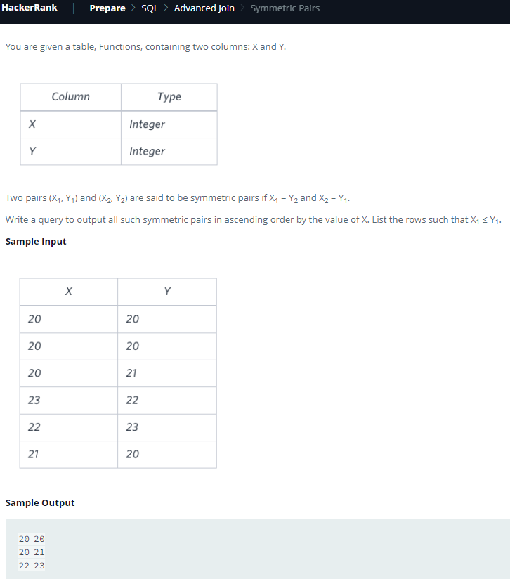

with F(sno,x,y) as (select row_number() over(order by x),Functions.* from Functions)

select f1.x,f1.y from F f1 inner join F f2 on f1.sno<f2.sno and f1.x=f2.y and f2.x=f1.y

where f1.x<=f1.y

order by f1.x;

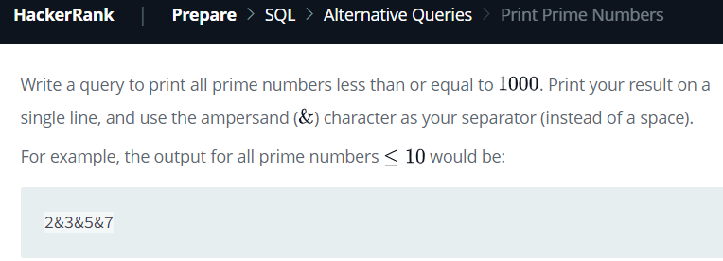

with

recursive AllNumbers(n) as (select 1 union all select n+1 from allNumbers where n<1000)

select group_concat(Num.n separator '&') from AllNumbers Num

where not exists(select n from AllNumbers FactorsOfNum where FactorsOfNum.n>1 and FactorsOfNum.n<Num.n and Num.n%FactorsOfNum.n=0) and Num.n>1;

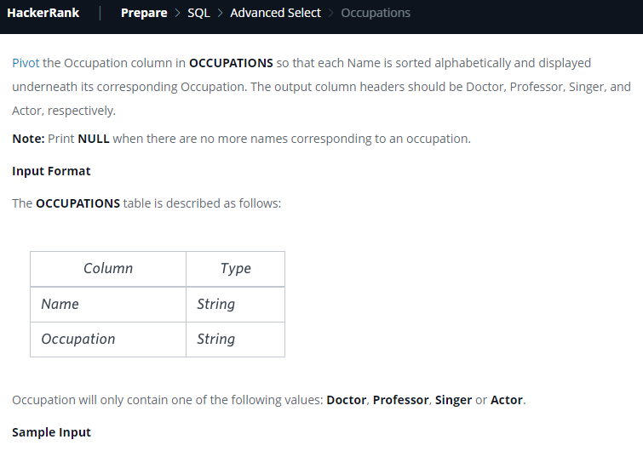

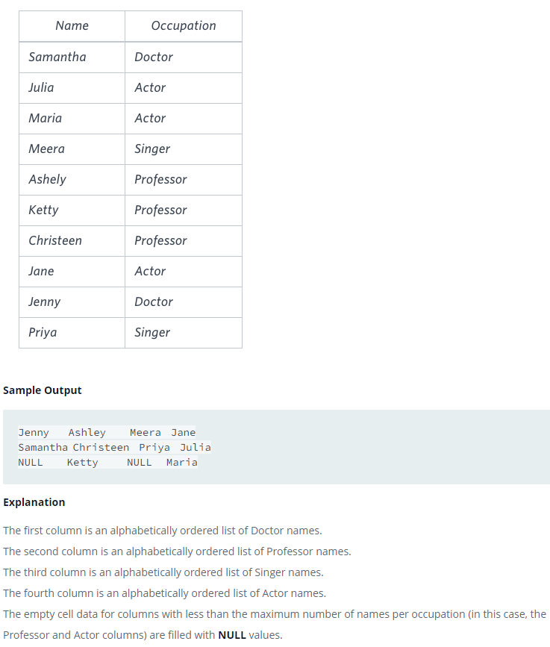

select

min(case when occupation='Doctor' then Name end),

min(case when occupation='Professor' then Name end),

min(case when occupation='Singer' then Name end),

min(case when occupation='Actor' then Name end)

from (select name, occupation, row_number() over (partition by occupation order by name) as Sno from Occupations) T

group by T.Sno;

/*First partition the Occupation table by Occupation and put Serial No for each Name within the Occupation. Note that this serialNo corresponds to the rowNumber for output.

Now group using SerialNo. For each given occupation and serial no, one single name can be selected. Use any aggregate function(either min/max with name) since we have to use 'group by serialNo'.

Also note: don't leave space after min. e.g. Wrong:"min (case...)". Correct:"min(case...)". Idk the reason but that space causes Error. */

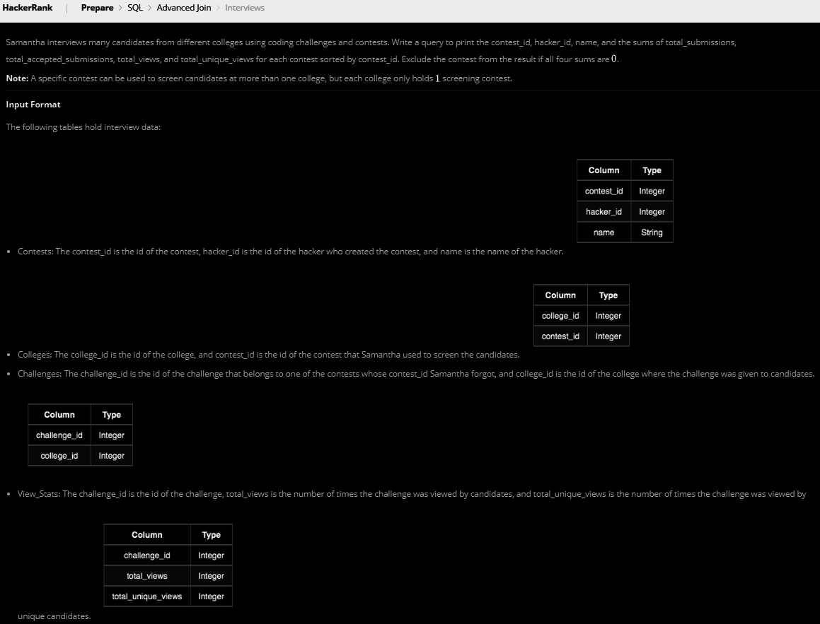

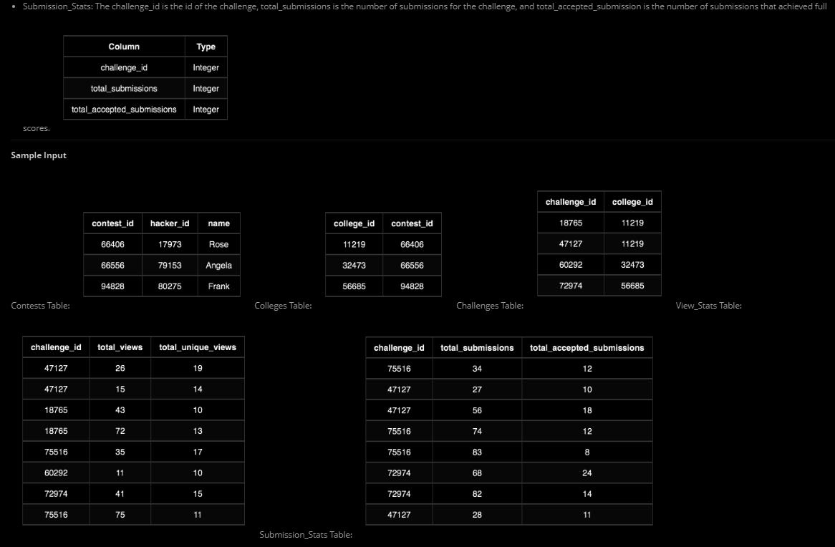

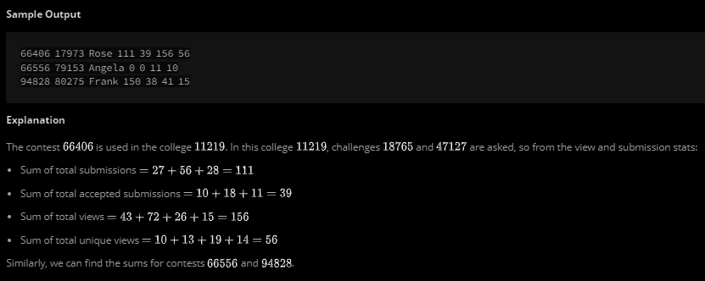

Language: MS SQL Server

select

Con.contest_id, Con.hacker_id, Con.name, sum(SS.ts), sum(SS.tas), sum(VS.tv), sum(VS.tuv)

from

Contests Con

inner join Colleges Col on Col.contest_id=Con.contest_id

inner join Challenges Cha on Cha.college_id=Col.college_id

left join (select challenge_id, sum(total_submissions) ts, sum(total_accepted_submissions) tas from Submission_Stats group by challenge_id) SS on SS.challenge_id=Cha.challenge_id

left join (select challenge_id, sum(total_views) tv, sum(total_unique_views) tuv from View_Stats group by challenge_id) VS on VS.challenge_id=Cha.challenge_id

group by Con.contest_id, Con.hacker_id, Con.name

order by Con.contest_id;

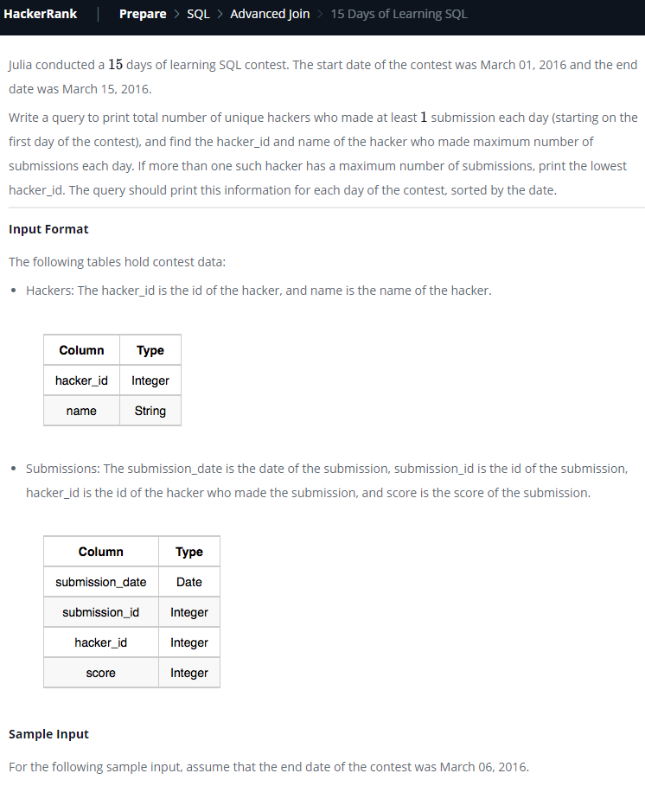

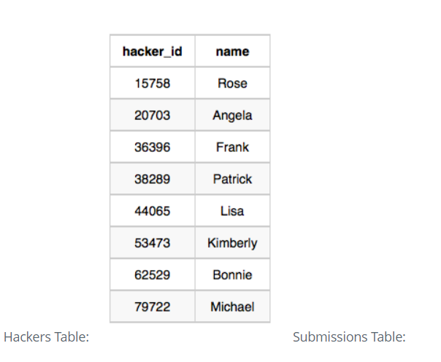

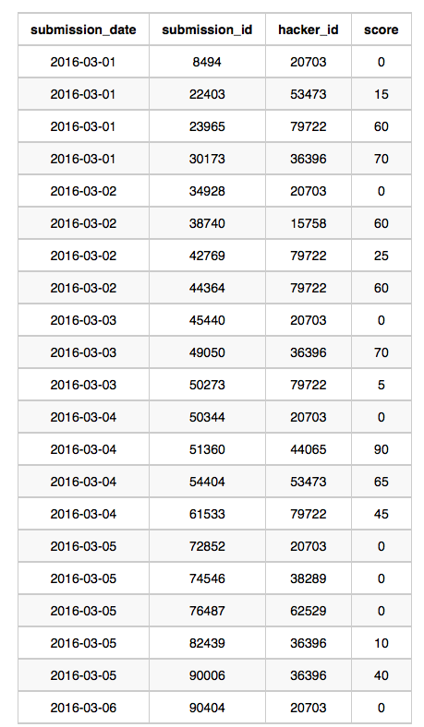

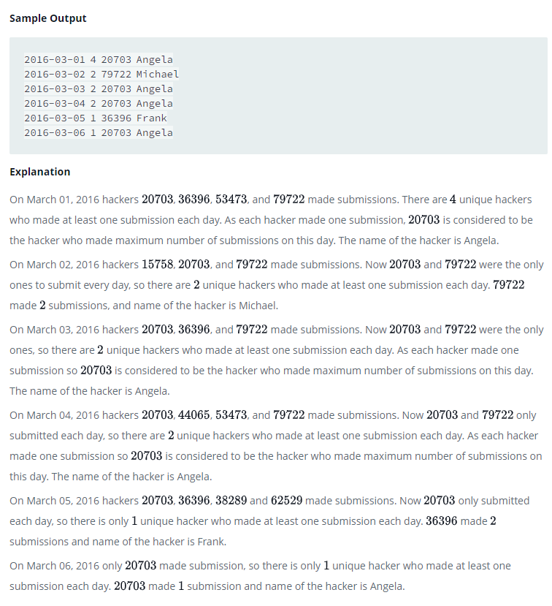

Language: MS SQL Server

with

-- Query Q1 appends submissions Table with dateRank and hackerDates ranking columns

Q1 as

(select

submission_date,

submission_id,

hacker_id,

dense_rank() over (order by submission_date) as dateRank,

-- This column calculates such that Mar 1 corresponds to 1, Mar 2 corresponds to 2 ,... Mar 15 corresponds to 15

dense_rank() over (partition by hacker_id order by submission_date) as hackerDates

-- This column calculates the no of days participated by each hacker_id starting from 1 Mar,2016 corresponding to each date from Mar 1-15 2016.

--E.g. on Mar 10, for hacker_id=A, if hackerDates=10 then that means A has been playing on all the 10 days (Mar 1-10)

from submissions),

-- For each submission_date, the query Q2 calculates the number of unique hacker_ids who made at least one submission every day from Mar 1 to submission_date

Q2 as

(select

submission_date,

count(distinct hacker_id) as UniqueHackerCount

from Q1

where dateRank=hackerDates

group by submission_date),

-- For each submission_date, Query Q3 Calculates the hacker_id with max number of submission each day. If more than one such hacker_id, only the lowest hacker_id is shown.

Q3 as

(select distinct

submission_date,

first_value(hacker_id) over(partition by submission_date order by count(submission_id) desc, hacker_id) as MaxSubmissionHackerId

from

submissions

group by submission_date, hacker_id)

select Q2.submission_date, Q2.UniqueHackerCount, Q3.MaxSubmissionHackerId, H.name as MaxSubmissionHackerName

from

Q2

inner join Q3 on Q2.submission_date=Q3.submission_date

inner join Hackers H on H.hacker_id=Q3.MaxSubmissionHackerId

order by submission_date